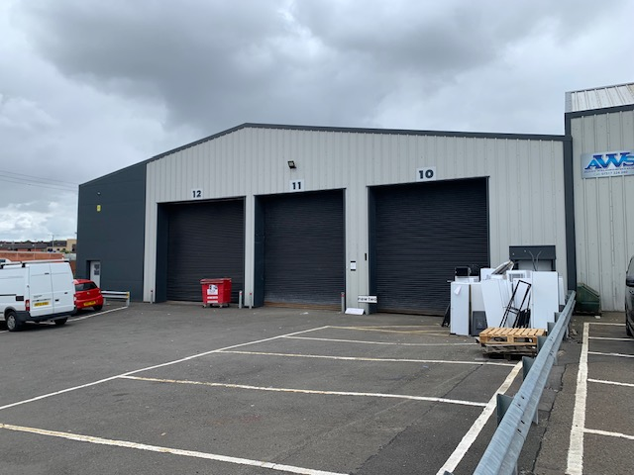

LOCATION

Edmiston trade park is located at the junction of Edmiston Drive and Broomloan Road. The M8 motorway is located a short distance from the estate, accessed from junctions 23 and 24.

DESCRIPTION

The subjects comprise a recently refurbished warehouse unit situated within a gated estate. The unit is of steel frame construction; elevations and the roofs are of Kingspan design The building provides the following approximate floor area.

Ground Floor | 618.064 sq m | 6,650 sq ft
Mezzanine | 266.172 sq m | 2,864 sq ft
Total | 1,150.408 sq m | 9,514 sq ft

RENTAL

The subjects are available by way of a new five-year lease at an initial rental of more than £47,500 per annum.

RATEABLE VALUE

The subjects are entered into the current valuation role at Rateable Value £37,750.

EPC

EPC can be made available on request

LEGAL COSTS

In the normal manner, each party will be responsible for their own legal costs with the tenant being responsible for land and building transaction tax and registration dues
VAT.

VAT

Unless otherwise stated, our prices, premiums and rents are quoted exclusively of value added tax. Any interested party must satisfy themselves independently as to the incidence of VAT in respect of any transaction.

VIEWING

Strictly by appointment via: -

Reith Lambert

Drew Lambert
07803 136214
awl@reithlambert.co.uk

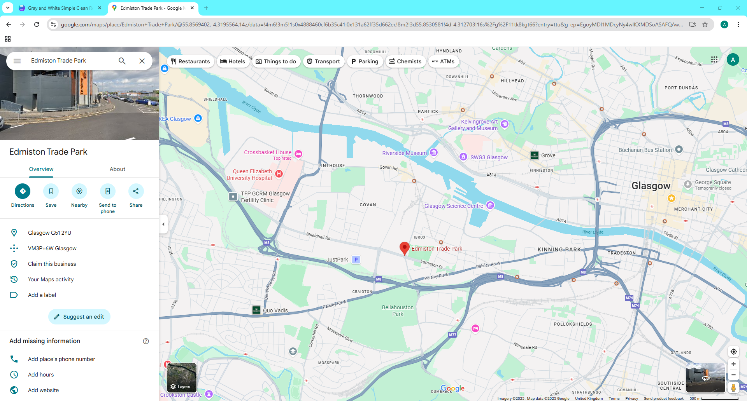

24 Blythswood Square, Glasgow G2 4BG 0141 221 7575 reithlambert.co.uk

